BUTLER RECREATION DEPARTMENT
Now Offering
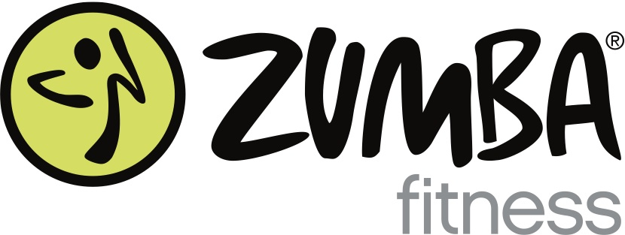

ARE YOU READY TO PARTY YOURSELF INTO SHAPE?

**NEW SESSION STARTS SEPTEMBER 17**
Tuesday: 7:30pm
Aaron Decker School Gym

Ten Weeks - $70 Drop-ins welcome anytime for $10

Sign up through the Butler Recreation Department
1 Ace Rd
(973) 838-7903

Or Contact Maria for more details:
(973) 750-8505

Classes taught by local licensed instructor mariaheyburn.zumba.com

.

