BUTLER RECREATION DEPARTMENT
Now Offering
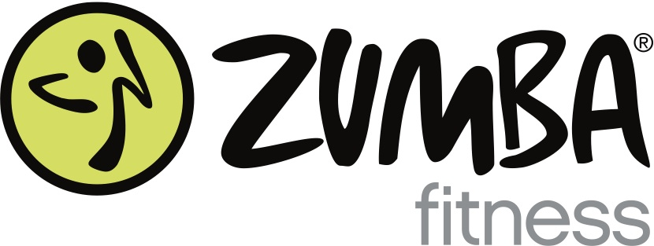

NEW YEAR – NEW YOU!
Join your friends and neighbors for a fun, easy-to-follow, exhilarating, effective Dance Fitness class.

**NEW SESSION STARTS JANUARY 7, 2014**
Tuesday: 7:15pm
Aaron Decker School Gym

Ten Weeks - $70 Drop-ins Welcome Anytime for $10

Sign up through the Butler Recreation Department
1 Ace Rd
(973) 838-7903

Or Contact Local Licensed Instructor Maria Heyburn for more details:
(973) 750-8505

.

